Original Plan Section:
Tool Analysis
- Lucidchart: While the free tier offers a capable node-based canvas for flowcharts and PERT diagrams, the Gantt functionality is limited. The platform requires manual formatting for timelines and lacks automatic calculation for task dependencies.
- TeamGantt: This specialized tool features a drag-and-drop interface that automates duration and overlap calculations. However, it does not support the custom node-based architecture required for PERT charts.
- Draw.io (diagrams.net): Although it is an open-source, cost-effective solution for custom PERT node shapes, it offers no timeline automation, making Gantt chart creation a purely manual and inefficient process.
- Microsoft Project: As the industry standard, it handles both PERT and Gantt generation concurrently. However, the licensing costs and steep learning curve make it impractical for this project.
Selection & Justification
The group opted to use Lucidchart for the PERT chart and TeamGantt for the Gantt chart.
We selected Lucidchart for the PERT requirements because its interface allows us to instantiate custom node shapes to display specific variables, task name, expected time, Earliest/Latest Start and Finish times, and slack time, without a paywall.
For the Gantt chart, we chose TeamGantt to prioritize efficiency. Rather than manually drawing bars in a general diagramming application, TeamGantt’s dedicated engine allows us to visualize start times, task durations, and resource allocation. This approach bridges the gap between high-level planning and precise execution while staying within the project’s free software requirement.

Task Time & Roadblock Table

Tasks-
- Initial Setup (Getting book number and other info)
  - Unclear instructions
- Going to the library- best case scenario: 3 mins, worst case: 10 mins (Aleksandra, Zoe)
  - Falling (injury)
  - Snow (bad weather)
- Go to the MECC Printer
  - The keycard doesn’t work
  - The printer is out of paper
  - No more printing dollars
- Finding the book-
- The book is lost/missing/displaced
- Forgotten call name
- Travel back to MEC: 3 mins, worst case: 10 mins (Aleksandra, Zoe)
  - Fall
- Transcribing the book
  - Backwards transcription is improperly understood
  - The pages are missing
- Proofread
  - Major error found.
- Printing the transcription
  - Printer jam
- Email Transcription
  - Wifi Drops out
- Hand Deliver to Professor
  - Dr. S stepped out of the classroom

The Expected Time calculation uses the formula: (Optimistic + (4 * Most Likely) + Pessimistic) / 6.

Task | Setbacks | Resolution Options | Additional Time for Setback | Optimistic Time | Pessimistic Time | Most Likely Time | Expected Time
A. Initial Setup |  |  |  | 2 min | 4 min | 3 min | 3 min
 | Unclear Instruction | Clarify with the Professor | +2 min
B. Going to the Library |  |  |  | 3 mins | 18 | 4 min | 6 mins
 | Falling (injury) | If a health center is needed, alert the team. | +10 min
 | Snow (bad weather) | Take indoor paths. | +5 min
C. Finding the book |  |  |  | 3 | 21 | 4 | 7 min
 | The book is lost/missing/displaced | Try to find a library attendant | +15
 |  | Contact dr. S | +3
D. Finding the page |  |  |  | 3 min | 6 | 4 | 5 min
 | The pages are missing | Contact Dr. S | + 3 min
E. Travel back to the MECC |  |  |  | 5 | 18 | 4 | 7 min
 | Falling (injury) | If a health center is needed, alert the team. | +10 min
 | Snow (bad weather) | Take indoor paths. | +3 min
F. Transcribing the book |  |  |  | 10 | 27 | 15 | 16 min
 | Backwards transcription is improperly understood | Teammates will recover the paragraph | +7 mins
 | The pages are missing | Contact dr S | +10 mins
G. Travel to MECC printer |  |  |  | 1 min | 19 mins | 4 mins | 6 mins
 | Falling | Send another team member and call for help | +5
 | Unable to get in the door/No ID access | Try basement printer | +3 mins
 |  | Try LSC Printer | +10 mins
H. Email Transcription |  |  |  | 2 mins | 7 min | 4 min | 4 min
 | Wifi Drops out | Use phone hotspot | +1 min
 | MFA doesn’t send authentication token so can’t log into email | Another teammate will take over | +4 mins
I. Printing |  |  |  | +1 min | +3 min | 2 min | 2 min
 | Printer jam | Fix jam | +2 min
J. Proofreading |  |  |  | 3 mins | 6 mins | 4 mins | 4 min
 | Major error found. | Split up the paragraph into the # of teammates able to type and work together | +3 mins
K. Hand Deliver |  |  |  | 4 mins | 6 mins | 5 min | 5 mins
 | Dr. S stepped out of room | Check her office and send an email | +2 min

Task Name | Expected Time | Predecessors
A. Initial Setup | 3 mins | None
B. Going to the Library | 6 mins | A
C. Finding the book | 7 mins | B
D. Finding the page | 5 mins | C
E. Travel back to the MECC | 7 mins | D
F. Transcribing the book | 16 mins | D
G. Travel to the MECC printer | 6 min | None
H. Printing | 4 min | J
I. Email Transcription | 4 min | J
J. Proofreading | 4 mins | F
K. Hand Deliver to Dr. S | 5 mins | H,I

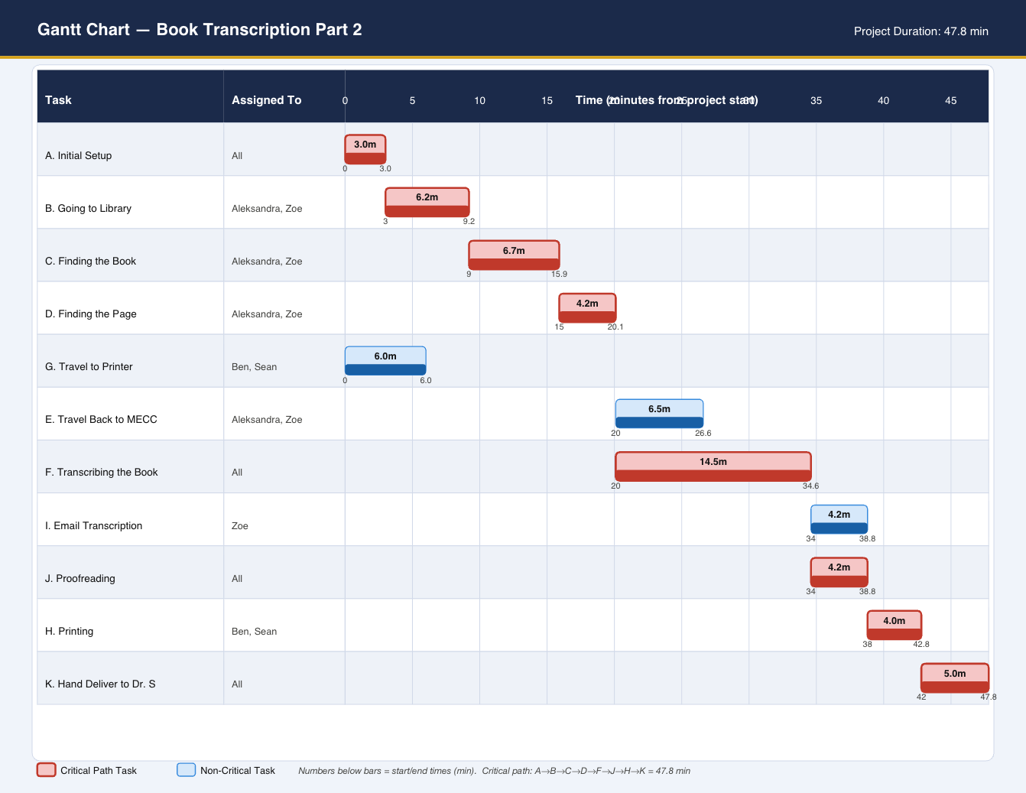
Pert Chart: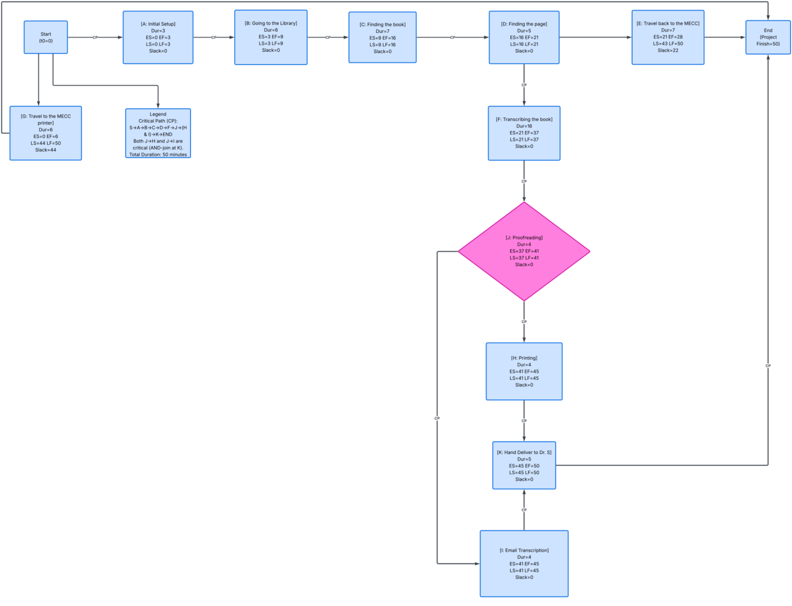

Experience Section:

Task | Setbacks | Resolutions | Original O/P/ML | Original Exp. | Actual Time
A. Initial Setup | Unclear instructions | Clarify with the professor | O=2 / P=4 / ML=3 | 3 min | 0 min
B. Going to the Library | Falling (injury)  Snow (bad weather) | Alert team if injury  Take indoor paths | O=3 / P=18 / ML=4 | 6 min | 3 min
C. Finding the correct Book | Book lost/missing/displaced  Pages missing  Wrong call number given | Ask library attendant  Contact Dr. S  Googled correct call number | O=3 / P=21 / ML=4 | 7 min | 4 min
D. Finding the Page | (Not in original plan)  Assigned page did not exist — book ended at p. 347, assignment referenced p. 351 | Contacted Dr. S for correct page | O=2 / P=10 / ML=4 | 5 min | 2 min
Wait / Sync Delay | (Not in original plan)  Waiting for professor reply after email sent | Wait for email confirmation before proceeding | O=1 / P=15 / ML=4 | 5 min | 1 min
E. Travel Back to the MECC (was D) | Falling (injury)  Snow (bad weather) | Alert team if injury  Take indoor paths | O=5 / P=18 / ML=4 | 7 min | 6 min
F. Transcribing the Book (was E) | Backwards transcription misunderstood  Pages missing | Teammates recover the paragraph  Contact Dr. S | O=10 / P=27 / ML=15 | 16 min | 14 min
G. Travel to MECC Printer (was F) | Falling  No ID access to door | Send another team member / call for help  Try basement printer then LSC | O=1 / P=19 / ML=4 | 6 min | 3 min
J. Proofreading (was I) | Major error found  Some incorrect words found | Split paragraph among teammates, work together  Retyped affected sections | O=3 / P=6 / ML=4 | 4 min | 9 min
I. Email Transcription (was G) | Wi-Fi drops out  MFA token not received | Use phone hotspot  Teammate sends from their account | O=2 / P=7 / ML=4 | 4 min | 1 min
H. Printing (was H) | Printer jam  Keycard doesn't work  Out of paper / toner | Fix jam  Go to LSC / basement printer | O=1 / P=11 / ML=3 | 4 min | 1 min
K. Hand Deliver (was J) | Dr. S stepped out of room  Two wrong locations visited | Check office; send email confirming attempt  Followed clues to correct location | O=4 / P=6 / ML=5 | 5 min | 4 min

Final timeline:
- Travel to library - 3mins (7:47- 7:50)
- Travel to printer- 3 mins (7:47 - 7:50)
- Finding the book- 4 mins (7:50 - 7:54)
- Finding the page- 2 mins (7:54 - 7:56)
- Delay- 1 min(7:53-7:56)
- Transcribing - 14 mins (7:57- 8:11)
- Travel back to MECC- 6 mins (7:56- 8:02)
- Proofreading - 9 mins (8:02- 8:11)
- Email transcription- 1 min (8:11- 8:12)
- Printing- 1 min(8:11- 8:12)
- Hand deliver- 4 min (8:12 - 8:16)

Learning From Experience:

Clean Lessons-Learned Task Table:
Task | Setbacks | Resolution | Opt. | Pess. | Most Likely | Expected | Pred.
A. Initial Setup | Unclear instructions | Clarify with professor before proceeding | 2 | 5 | 3 | 3 | None
B. Going to the Library | Bad weather; injury; wrong call number listed | Verify call number before going; indoor routes | 3 | 15 | 5 | 6 | A
C. Finding the Book | Book displaced, checked out, or wrong item at call number | Ask library staff; re-verify call number on the spot | 2 | 15 | 4 | 6 | B
D. Finding the Page | Assigned page does not exist; wrong page given | Check page count immediately; contact professor if discrepancy | 2 | 12 | 4 | 5 | C
Wait / Sync Delay | Professor slow to respond; email not received | Follow up via Teams after 5 min; do not proceed until confirmed | 1 | 15 | 4 | 5 | D
E. Travel Back to MECC | Bad weather; injury | Indoor routes; send book photos ahead so typing starts | 3 | 12 | 5 | 6 | Wait
F. Transcribing the Book | Typos; missing pages; misunderstood direction | Split paragraphs; proofread each paragraph real-time | 10 | 25 | 13 | 14 | Wait
G. Travel to Printer | Keycard denied; no paper/toner; no print credits | Verify printer access before leaving; basement/LSC backup | 1 | 10 | 4 | 5 | None
J. Proofreading | Errors requiring retype | Non-typist proofreads aloud; correct immediately | 3 | 10 | 4 | 4.5 | F
I. Email Transcription | Wi-Fi drops; MFA token issues | Phone hotspot; teammate sends if needed | 2 | 7 | 3 | 3.5 | J
H. Printing | Printer jam; no toner; keycard denied | Load paper before arriving; basement/LSC backup | 1 | 8 | 2 | 2.5 | J
K. Hand Deliver | Professor not in room; wrong location visited | Confirm room before leaving; check office if empty | 2 | 10 | 4 | 5 | I, H

Gantt Chart:
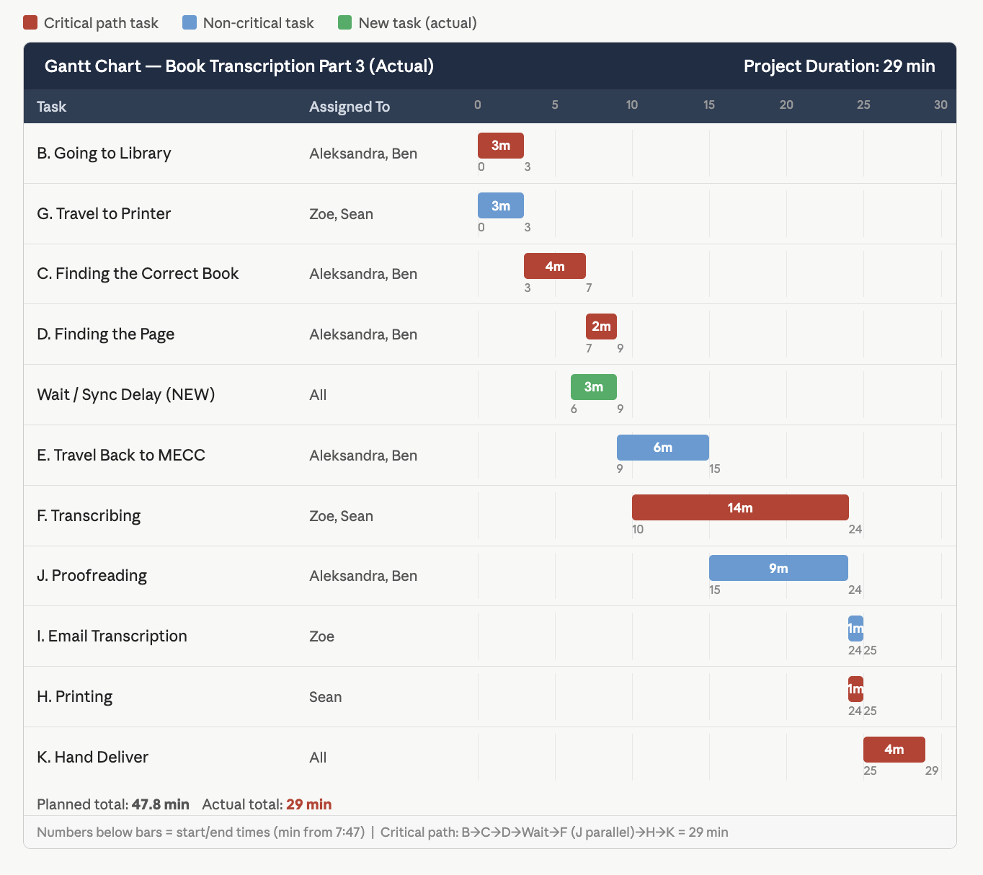

PERT Chart:
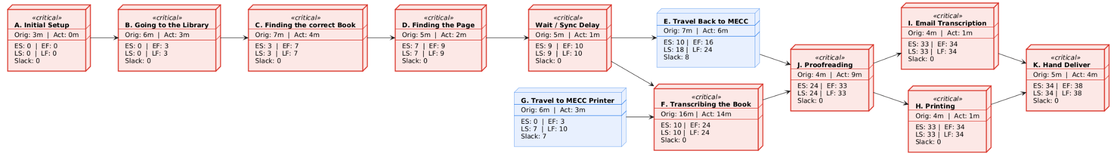

Reflections:

What Went Well
- Team communication was fast and effective. The iMessage group chat allowed real-time coordination between the library team and the MECC team. Photos of book pages, Dr. Spezialetti's reply, and the book's index were all shared within seconds.
- Contacting Dr. Spezialetti worked. When the assigned page (p. 351) did not exist in the library copy, the team emailed Dr. S immediately and received a clear reply — "Try 237" — within one minute. This is exactly the right Agile behavior: escalate to the client whenever a decision would affect the final product.
- Transcription came in well under estimate; 12 minutes actual vs. 16 minutes estimated (8:00–8:12 PM). Splitting paragraphs among team members and proofreading in real time drove this improvement.
- Several tasks finished faster than estimated: finding the book (3 vs 7 min), travel back to MECC (6 vs 7 min), email (2 vs 4 min), printing (2 vs 4 min), and hand delivery (3 vs 5 min).
- The wrong call number was resolved quickly by Googling the correct one on the spot, keeping the project moving without requiring a return trip or further escalation.

What Didn't Go Well
- The assigned page number (p. 351) did not exist in the library copy of Rethinking Home Economics, which ended at p. 347. This was not anticipated in the original plan and required adding a new task (D. Finding the Page) mid-execution, plus an unplanned communication loop with the professor.
- The initial call number led to difficulty locating the book. The team had to look up the correct call number independently (TX 392 .E84 1999). The original plan did not include a step to verify the call number before going.
- The Wait/Sync Delay task (3 minutes) was entirely absent from the original plan. Any project requiring the professor's input mid-execution must budget time for response latency.
- Proofreading turned up incorrect words requiring retyping, pushing J from the estimated 4 minutes to 5 minutes. Paragraph-by-paragraph proofreading during transcription would catch these earlier.
- Hand delivery required visiting two wrong locations before finding the correct one. The delivery destination should always be confirmed before leaving the printer.

Lessons Learned
- Verify the call number independently before going to the library — do not rely solely on the number given in the assignment. A quick search on the Trinity College Library website confirms the correct shelf location and prevents a wasted trip.
- Check the book's page count immediately upon finding it. If the assigned page number exceeds the actual page count, contact the professor before leaving the library. Do not assume the reference is correct.
- Add a Wait/Sync Delay task to every future plan that involves professor input. Budget 5 minutes minimum. This is a predictable, recurring component of any client-dependent project.
- Proofread each paragraph in real time as it is typed. This surfaces errors immediately while context is fresh, reduces total proofreading time, and avoids compounding errors across multiple paragraphs.
- The original plan's estimated total (47 min) was overestimated by 7 minutes. For future planning, tighten estimates.
- Total actual time: 41 minutes. Typing phase: 8:00–8:12 PM (12 min). The largest savings came from transcription (4 min under), driven by splitting the work across team members.

